Restaurant Review Sentiment Analysis using Generative AI

Project Description:

Restaurants receive enormous volumes of customer reviews across platforms. Manual reading is inefficient and inconsistent. Traditional ML models fail to interpret context, mixed feelings, or sarcasm.
Therefore, there is a need for a Generative AI-powered system that can analyse reviews intelligently and provide reliable sentiment outputs.

Restaurants rely heavily on customer feedback to improve service and food quality. However, with thousands of online reviews, it becomes difficult to extract meaningful insights manually.
Generative AI offers a modern solution by enabling machines to understand human language at an advanced level. Instead of using old ML algorithms like Naïve Bayes or SVM, this project uses LLM embeddings to deeply analyse sentences, detect tone, understand context, and provide accurate sentiment predictions.

This project focuses on building a real-time web application where users can input any restaurant review and receive a sentiment classification instantly.

Project Scenarios
Scenario 1: Real-Time Customer Feedback Monitoring
A popular restaurant collects thousands of customer reviews daily across platforms like Yelp, Zomato, and Google Reviews. The Generative AI-based Restaurant Review Sentiment Analysis system processes each review in real time, analysing sentiment and identifying whether feedback is positive, negative, or mixed. This allows restaurant managers to instantly detect dissatisfied customers and take corrective actions such as addressing service delays, improving food quality, or providing compensation to maintain customer satisfaction.
Scenario 2: Brand Reputation Management for Restaurant Chains
A multi-location restaurant chain wants to evaluate customer perception across different branches. The system bulk-processes large datasets of Yelp reviews using Generative AI, categorizing sentiment and highlighting key performance aspects like service speed, hygiene, pricing, and taste. Management receives automated insights and comparative performance analytics that help them identify underperforming branches, allocate improvement budgets strategically, and enhance brand reputation.
Scenario 3: Market Research and Product Improvement

Before launching a new food item or promotional campaign, a restaurant group analyses customer opinions on social media and review platforms. The AI sentiment analysis system extracts frequently mentioned keywords and identifies recurring themes—such as feedback about spice levels, portion size, or packaging quality. The insights help chefs and marketing teams refine recipes, adjust pricing strategies, and design campaigns aligned with customer expectations, leading to market success.

Technical diagram:
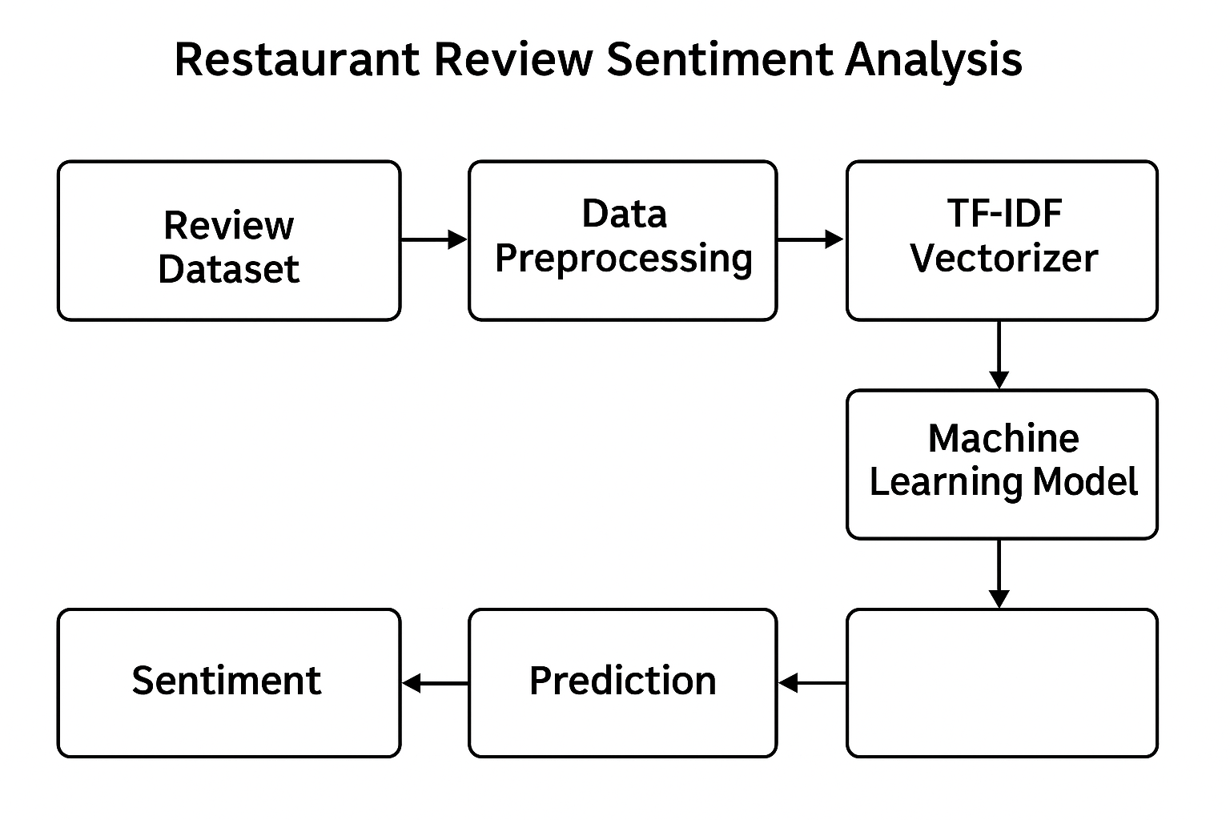

Prerequisites:
To complete this project, you must require the following software, concepts, and packages
- Visual Studio:
o Link: https://youtu.be/1ra4zH2G4o0
● Python packages:
    - Type “pip install numpy” and click enter.
    - Type “pip install pandas” and click enter.
    - Type “pip install scikit-learn” and click enter.
    - Type “pip install matplotlib” and click enter.
    - Type “pip install scipy” and click enter.
    - Type “pip install pickle-mixin” and click enter.
    - Type “pip install seaborn” and click enter.
    - Type “pip install Flask” and click enter.

Prior Knowledge:
You must have prior knowledge of the following topics to complete this project.
- ML Concepts
  - Supervised learning: https://www.javatpoint.com/supervised-machine-learning o Unsupervised learning: https://www.javatpoint.com/unsupervised-machine-learning o Logistic Regression: https://www.javatpoint.com/logistic-regression-in-machine-learning
  - Decision tree: https://www.geeksforgeeks.org/python-decision-tree-regression-using-sklearn/
  - Random forest: https://www.javatpoint.com/machine-learning-random-forest-algorithm
  - Evaluation metrics:
https://www.analyticsvidhya.com/blog/2019/08/11-important-model-evaluation-errormetrics/
  - Navie Bayes: https://www.javatpoint.com/machine-learning-naive-bayes-classifier
- Flask Basics: https://www.youtube.com/watch?v=lj4I_CvBnt0

Project Flow:
- User enters a restaurant review through the application interface (text input section)
- System preprocesses the review using NLP techniques such as tokenization, stop-word removal, and lemmatization
- Vectorization method (TF-IDF/Word Embeddings) transforms the text into numerical feature vectors
- Integrated machine learning model analyses
- the processed text to determine sentiment
- Prediction result (Positive / Negative / Neutral) is displayed along with confidence score
- System highlights key aspects and keywords such as food quality, service, ambiance, and pricing
- Actionable insights are generated to help management understand customer satisfaction trends

Project Activities:
Step 1: Dataset Collection
Yelp Open Dataset containing review text and ratings.
Step 2: Data Preprocessing
- Remove noise
- Lowercase
- Remove special characters
- Tokenization
Step 3: Embedding Generation
Use a pretrained embedding model such as:
- text-embedding-3-small
- paraphrase-MiniLM
Step 4: LLM Classification
Use LLM to classify the vector representation into sentiment.
Step 5: Web Deployment
Create a REST API using Flask/Fast API.
Build frontend form to accept user review.

Project Structure:
Create the Project folder which contains files as shown below

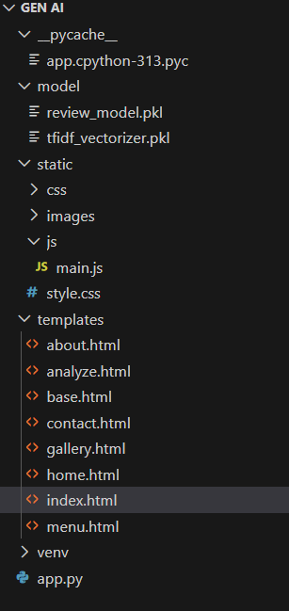

Project Structure Explanation
  - static/
Contains static assets (CSS, JavaScript, uploaded images)
○ style.css – Application styling

- templates/
HTML templates for Flask application

○ index.html – Landing page ● app.py
Flask application backend

- review_model.pkl
Trained model file

Milestone 1: Data Collection & Preparation
In this project, data is collected exclusively from the Yelp Open Dataset, which contains authentic restaurant customer reviews. The raw review text is cleaned by removing duplicates, special characters, and irrelevant content to improve quality. Further preprocessing steps such as stop-word removal, lemmatization, and lowercase conversion are applied to normalize the text. The dataset is then balanced and organized to provide reliable input for effective sentiment model training.

Activity 1.1: Collect the dataset
There are many popular open sources for collecting review datasets such as Kaggle, UCI Repository, and Yelp Open Dataset. In this project, we have used a. json/.csv review dataset from the Yelp Open Dataset. This dataset contains real customer restaurant reviews used for training the sentiment analysis model.

As the dataset is downloaded, the next step is to read and understand the data properly using various visualization and analytical techniques.
Note: There are several methods available for analysing data, but here we have used only a selected few. Additionally, you can apply multiple other techniques depending on the requirement.

Dataset Source: Yelp Open Dataset

The dataset used in this project contains textual restaurant reviews and their sentiment labels for classification. The dataset includes the following key fields:
- Review Text: Customer feedback written in text form
- Stars / Sentiment Label: Rating score used to determine sentiment (Positive / Negative / Neutral)
- Business ID: Unique identifier for each restaurant
- User ID: Identifier for the customer who provided the review

The dataset file contains thousands of real restaurant review entries used for training the sentiment analysis model.

Activity 1.2: Importing the Libraries
Import the necessary libraries as shown below:
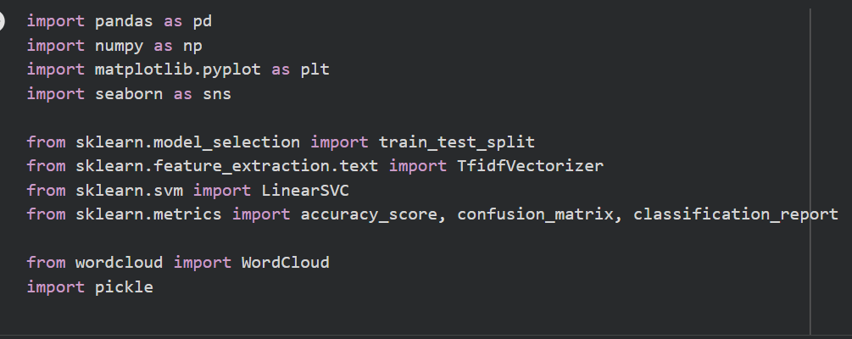
These libraries serve the following purposes:
- NumPy: For numerical computations
- Pandas: For data manipulation and analysis
- Matplotlib: For creating visualizations
- Seaborn: For statistical data visualization

Activity 1.3: Read the Dataset
Our dataset is in CSV format. We read the dataset using pandas:
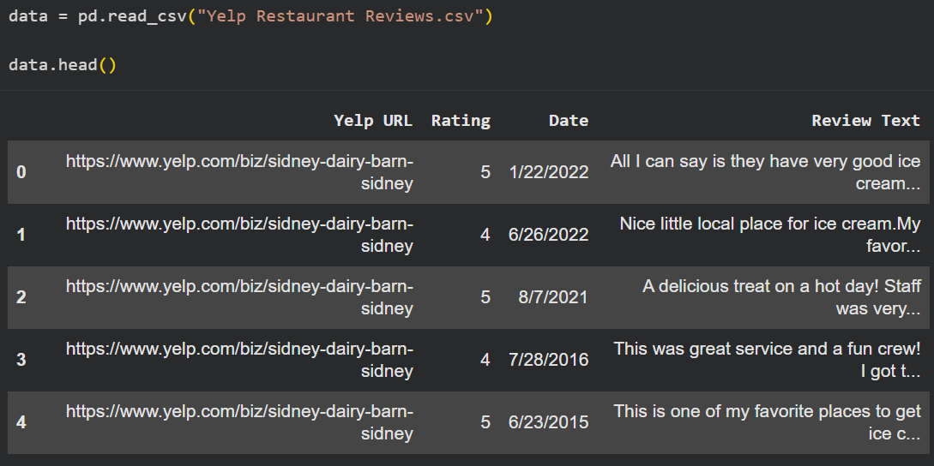
The head() function displays the first 5 rows of the dataset, giving us a quick overview of the data structure and values.

Activity 1.4: Data Processing
Raw text often contains noise such as punctuation, numbers, or inconsistent spacing.
This step applies preprocessing operations including:
- Converting text to lowercase
- Removing all non-alphabetical characters
- Removing extra spaces
- Normalizing the structure of each review
These cleaning operations help the machine learning model learn more effectively by focusing on meaningful words only.
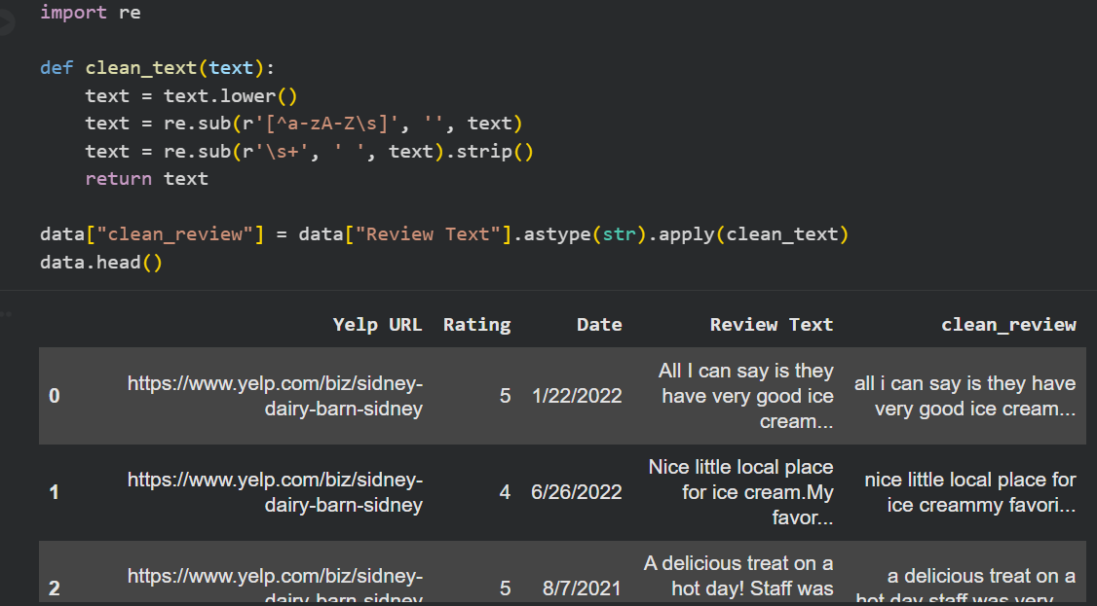

Activity 1.5: Splitting the datasets
The dataset is divided into two parts:
- Training set (80%)
- Testing set (20%)
The training set is used to teach the model, while the testing set is used to evaluate how well the model generalizes to new, unseen data.
This is achieved using Scikit-learn’s train_test_split() function.

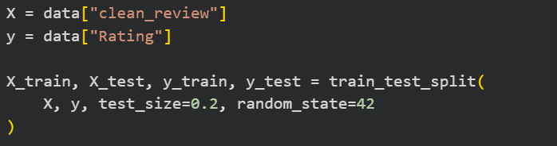
Step 2: TF-IDF Vectorization and Model Training
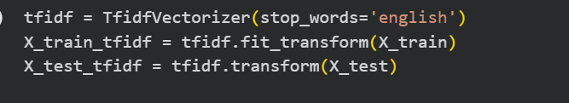
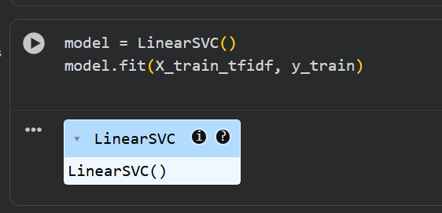
Text must be converted into numerical form before it can be used in machine learning.
This step uses TF-IDF Vectorization (Term Frequency – Inverse Document Frequency), which converts text into weighted numerical features based on how important each word is to the document.
After converting text to vectors, the Linear Support Vector Classifier (LinearSVC) is trained on the vectorized training data.
This model is effective for text classification problems such as sentiment analysi.

Step 3: Model Evaluation
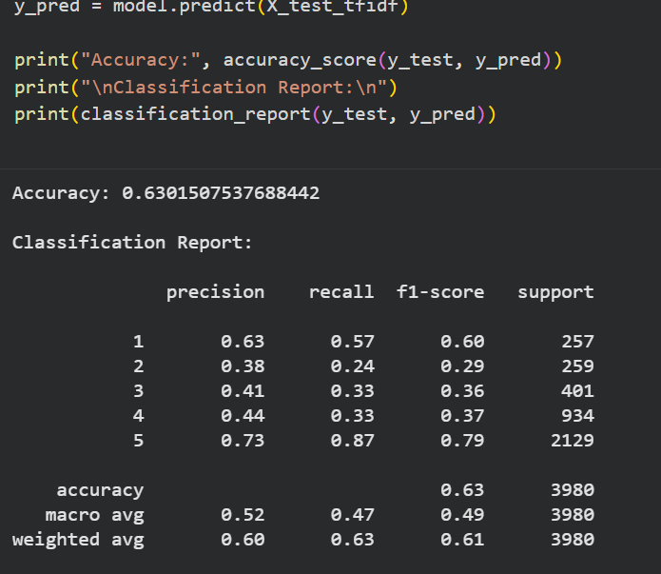

1.6: Confusion Matrix Visualization
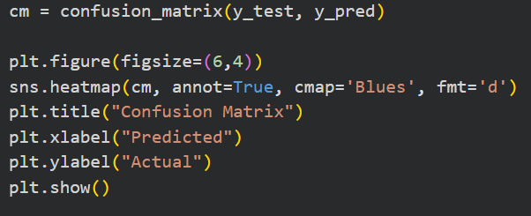
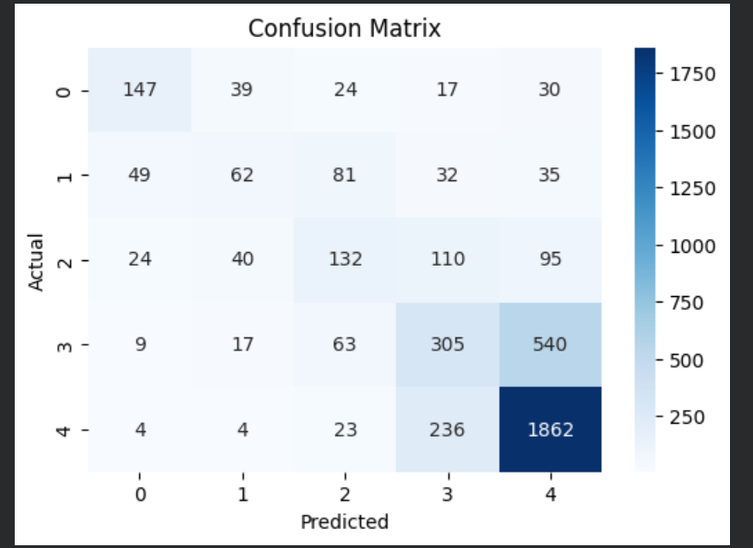

A confusion matrix is a tabular representation that shows how many predictions were correct and how many were misclassified.
Using Seaborn’s heatmap, the confusion matrix is visualized to better understand the distribution of correct and incorrect predictions for each class.

Activity 1.7: Word Cloud Generation
A word cloud visually represents the frequency of words in the dataset.
Frequently occurring words appear larger and bolder.
This step helps identify the most common terms used across restaurant reviews and provides qualitative insights into customer language patterns.
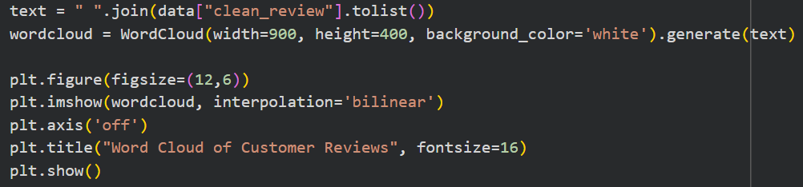

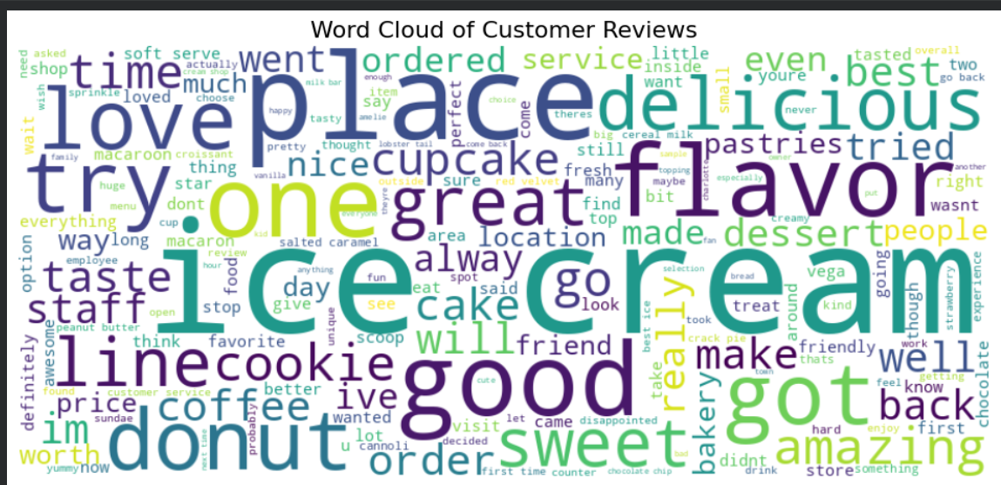
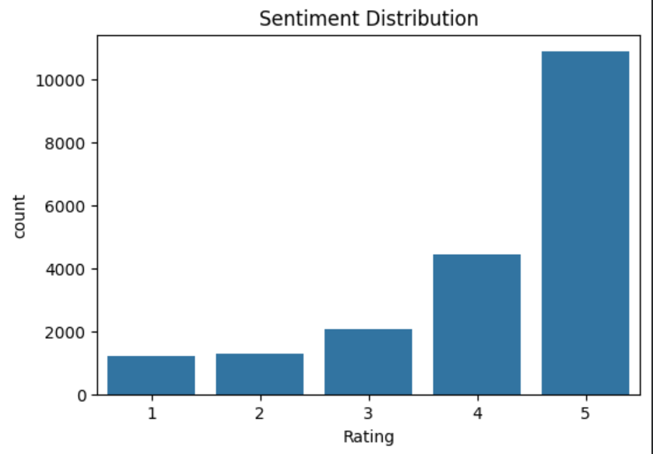

Activity 2.1: Save and download the model

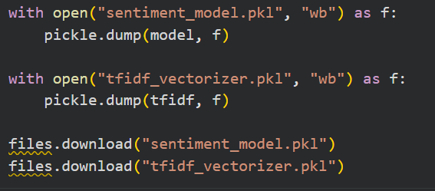
To reuse the trained sentiment analysis model outside Google Colab, it is saved as a .pkl file using Python’s pickle module.
The TF-IDF vectorizer is also saved, since it is required to convert new text into the same numerical format used during training.
Both files are downloaded to the local system for integration into applications (e.g., Flask web app).

Activity 2.3: Single Review Prediction
Finally, the user can manually input any review and obtain a predicted sentiment (Positive/Negative).
The text is cleaned using the same preprocessing steps, vectorized using the saved TF-IDF model, and passed into the trained SVM classifier.
This demonstrates real-time sentiment prediction capability.
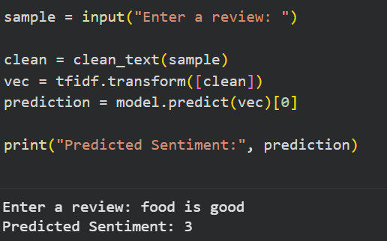

Activity 3.1: Flask Web Application Development
Application Architecture
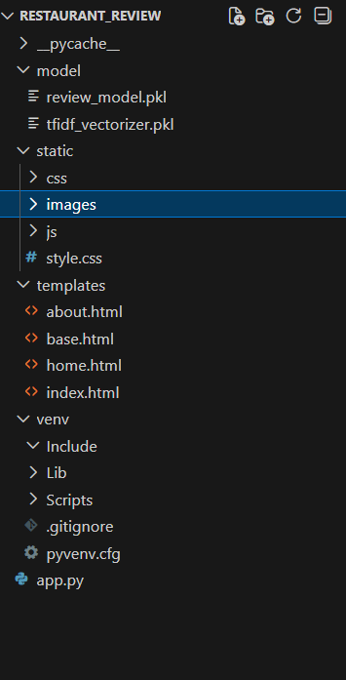

The application follows a standard Client–Server architecture designed for deploying a machine-learning–powered restaurant review sentiment analysis system.
● Client (Frontend Layer)
The frontend is implemented using HTML templates placed inside the templates/ directory.
It includes multiple user-facing pages such as:
- index.html → main homepage
- analyze.html → page where the user enters a restaurant review for analysis
- menu.html, gallery.html, about.html, contact.html → supporting pages of the restaurant website
The frontend provides a clean modern UI for user input and displays prediction outputs returned by the server.
CSS and JavaScript resources are served from the static/css, static/js, and static/images directories.
Backend Implementation (app.py)
The backend is developed using Flask, which acts as the main controller of the application.
It handles user requests, processes text, loads ML models, performs predictions, and renders templates.
Backend Responsibilities:
1. Model Loading
Upon application startup, the Flask server loads:
- review_model.pkl → trained sentiment classification model
- tfidf_vectorizer.pkl → TF-IDF transformer used for converting text to numerical features
Loading the models at startup improves performance and avoids reloading during each request.
2. Request Handling
When the user submits a review from analyze.html, the request is sent to the backend using:
@app.route('/predict', methods=['POST'])
Flask retrieves the review text submitted via the form.
3. Text Preprocessing
The backend applies the same preprocessing used during model training, ensuring consistency.
This includes:
- Lowercasing text
- Cleaning unwanted characters
- Converting to TF-IDF features using the loaded vectorizer
4. Prediction Execution
The processed text is fed into the trained ML model (LinearSVC) using:
prediction = model.predict(vectorized_text)
The output is a binary label:
- 1 → Positive Review
- 0 → Negative Review
5. Response Rendering
The prediction result is passed back to index.html or analyze.html, where it is displayed in a user-friendly message:
- “👍 Positive Review”
- “👎 Negative Review”

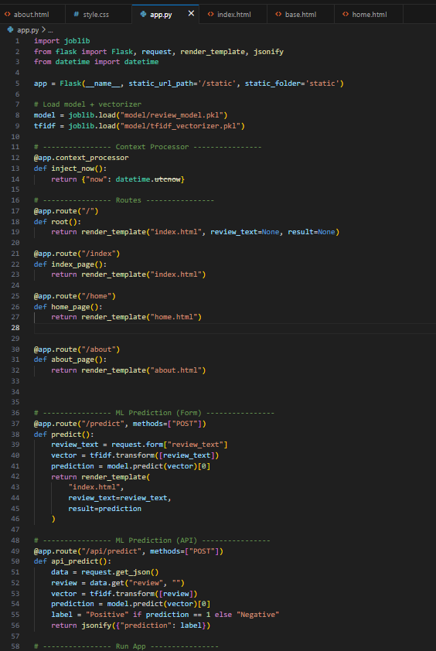

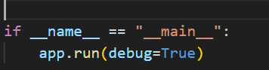
Frontend Implementation (HTML Templates)
The frontend uses Flask’s Jinja2 templating engine to dynamically render pages. All the pages inherit a consistent layout defined in base.html, improving code reuse and ensuring a uniform visual experience.
The main HTML pages include:
● base.html
Acts as the core page template.
Contains:
- Navigation bar
- Header layout
- Footer
- Blocks for inserting page-specific content
All other pages extend this template, ensuring consistent styling.
● index.html
Homepage of the restaurant website.
Features:
- Intro section
- Restaurant overview
- Call-to-action buttons
- Links to other sections
The page sets the tone for the website’s branding (Kleo).
● analyze.html
This is the core machine learning interaction page.
It contains:
- A text input box for entering a restaurant review
- "Analyze" and "Clear" buttons
- A results section where prediction output is displayed
This page communicates with the backend (/predict) through Flask's POST method.
● menu.html, gallery.html, about.html, contact.html
These pages provide static restaurant-related information including:
- Images
- Descriptions
- Contact form
- Restaurant details
Each page maintains the same styling and structure inherited from base.html.

2. CSS Styling (static/css/style.css)
The styling is defined in a central stylesheet located at:
static/css/style.css
Major responsibilities of the stylesheet:
- Provides responsive layout for mobile and desktop
- Styles navigation bar, buttons, forms, footers
- Defines a warm, modern restaurant theme
- Ensures color consistency across pages (orange/cream theme)
- Controls font size, spacing, margins, and paddings
The design emphasizes simplicity, readability, and professional aesthetics suitable for a restaurant website.

3. JavaScript (static/js/main.js)
While optional, a lightweight JavaScript file is included for:
- Small UI enhancements
- Smooth scrolling
- Form resetting
- Interactive effects
The application does not depend heavily on JavaScript because most dynamic operations occur server-side through Flask.

4. Images (static/images/)
This directory stores:
- Menu pictures
- Banner images
- Gallery items
Images are optimized for front-end performance and rendered through various template pages.

5. UI–Backend Interaction (Frontend → Flask)
The frontend communicates with the backend through HTML forms, specifically in analyze.html.

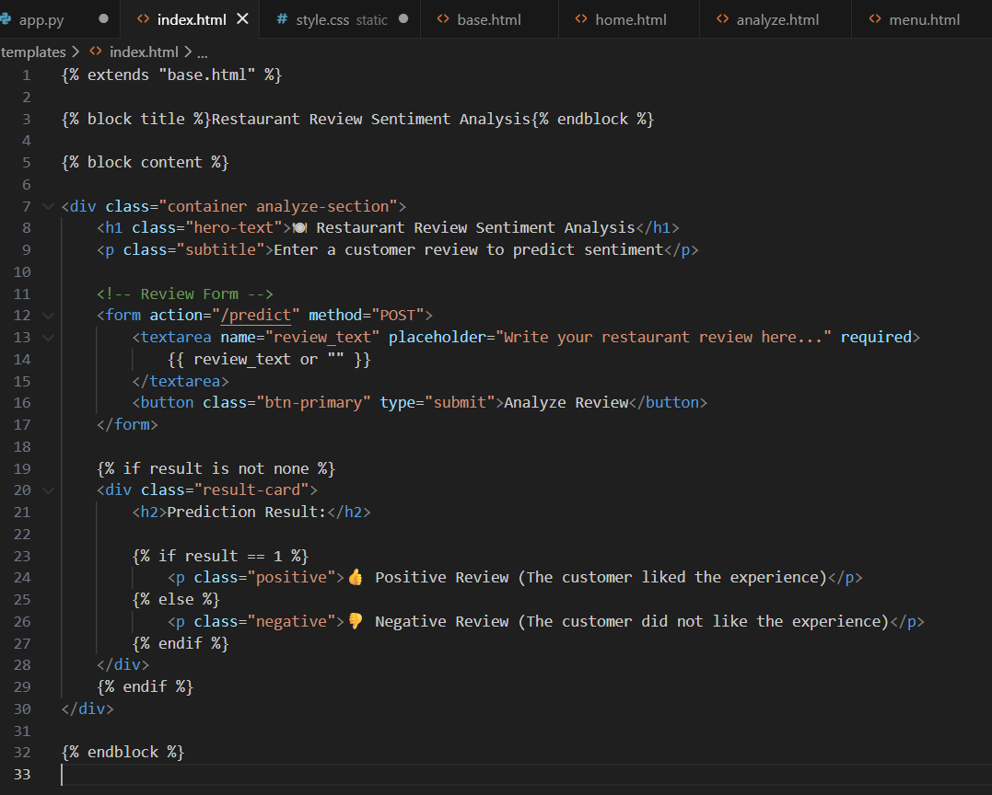

Application Screenshots and Workflow
The workflow moves sequentially from data input to clinical risk assessment.
- Home Page Interface (index.html)
  - Features: Clean, professional interface with clear headings and branding. All necessary inputs are available on a single screen for efficient data entry
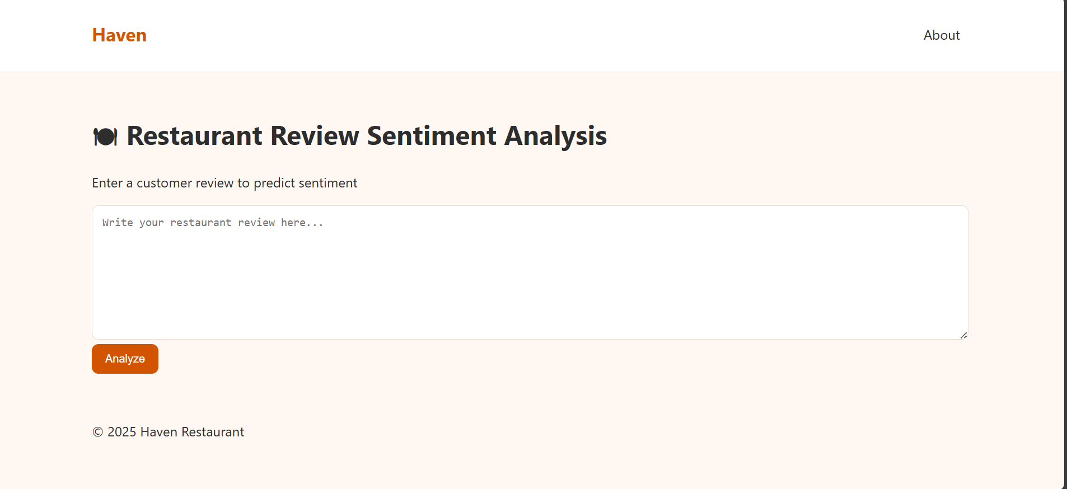
2.Analyze review
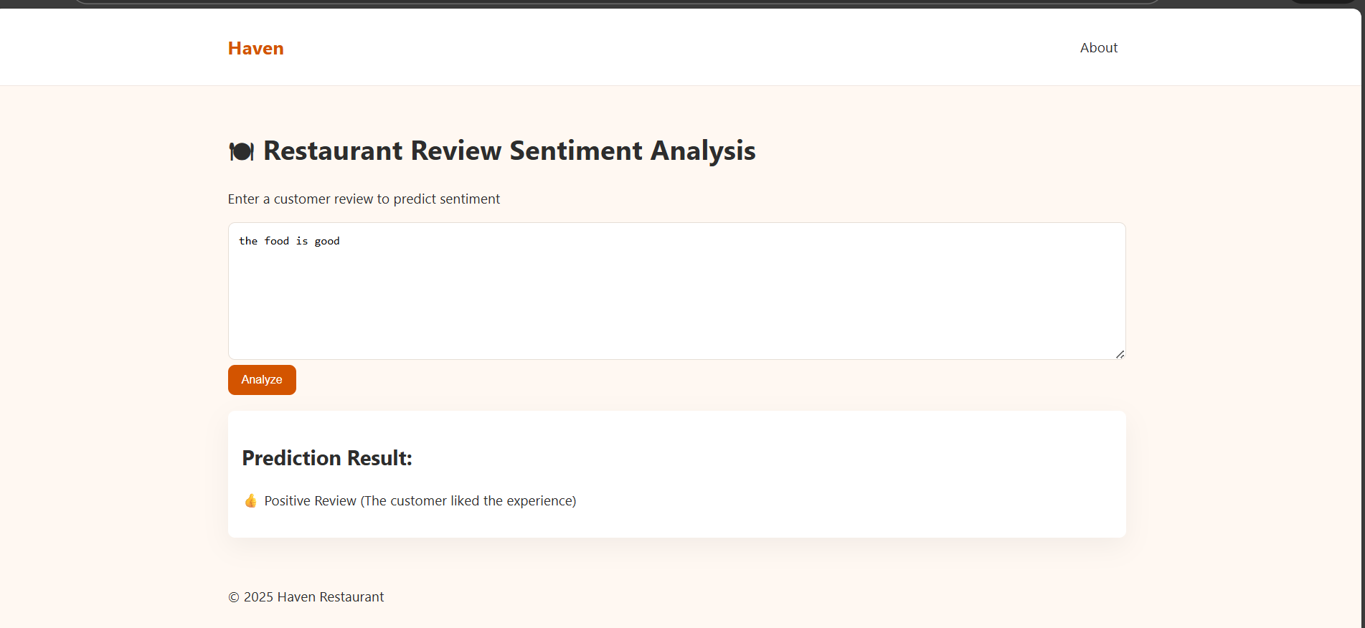

Future Implementations
The current system efficiently predicts the sentiment of restaurant reviews, but several improvements can make it more powerful and user-friendly. Future versions can integrate advanced deep-learning models like BERT for higher accuracy. Multilingual support may be added to analyze reviews written in different languages. The application can also be extended to perform aspect-based sentiment analysis, identifying opinions on food, service, ambience, and pricing. A real-time dashboard for restaurant owners can provide insights and trends. Finally, deploying the system to cloud platforms and adding a mobile app version would improve scalability and accessibility.

Conclusion
This project successfully demonstrates how Natural Language Processing and machine learning can be used to analyze restaurant reviews and classify them as positive or negative. The system offers a simple and effective web interface where users can enter reviews and instantly view predictions. Using a trained model and TF-IDF vectorizer ensures fast and reliable results. Overall, the application provides a practical solution for understanding customer feedback and can assist restaurants in improving service quality. With planned enhancements, the system has the potential to grow into a more advanced and comprehensive sentiment analysis platform.

